SAVEETHA SCHOOL OF ENGINEERING
SAVEETHA INSTITUTE OF MEDICAL AND TECHNICAL SCIENCES
COMPUTER SCIENCE AND ENGINEERING PROGRAMME
CSA04 – OPERATING SYSTEMS
Name: DHARANI KARTHICK
Reg no: 192521082

LIST OF PROGRAMS

5. Construct a scheduling program with C that selects the waiting process with the highest
priority to execute next.
#include <stdio.h>

int main() {
int n, i, j, temp;
int bt[100], wt[100], tat[100];
int priority[100], p[100];
float avg_wt = 0, avg_tat = 0;

printf("Enter the number of processes: ");
scanf("%d", &n);

// Read process details
for (i = 0; i < n; i++) {
p[i] = i + 1;

printf("Enter burst time for P%d: ", p[i]);
scanf("%d", &bt[i]);

printf("Enter priority for P%d (smaller number = higher priority): ", p[i]);
scanf("%d", &priority[i]);
}

// Sort processes by priority
for (i = 0; i < n - 1; i++) {
for (j = i + 1; j < n; j++) {
if (priority[i] > priority[j]) {
temp = priority[i];
priority[i] = priority[j];
priority[j] = temp;

temp = bt[i];
bt[i] = bt[j];
bt[j] = temp;

temp = p[i];
p[i] = p[j];
p[j] = temp;
}
}
}

// Calculate waiting time
wt[0] = 0;
for (i = 1; i < n; i++) {
wt[i] = wt[i - 1] + bt[i - 1];
}

// Calculate turnaround time and averages
for (i = 0; i < n; i++) {
tat[i] = wt[i] + bt[i];
avg_wt += wt[i];
avg_tat += tat[i];
}

avg_wt /= n;
avg_tat /= n;

// Display results
printf("\nProcess\tBurst Time\tPriority\tWaiting Time\tTurnaround Time\n");

for (i = 0; i < n; i++) {
printf("P%d\t%d\t\t%d\t\t%d\t\t%d\n",
p[i], bt[i], priority[i], wt[i], tat[i]);
}

printf("\nAverage Waiting Time = %.2f\n", avg_wt);
printf("Average Turnaround Time = %.2f\n", avg_tat);

return 0;
}

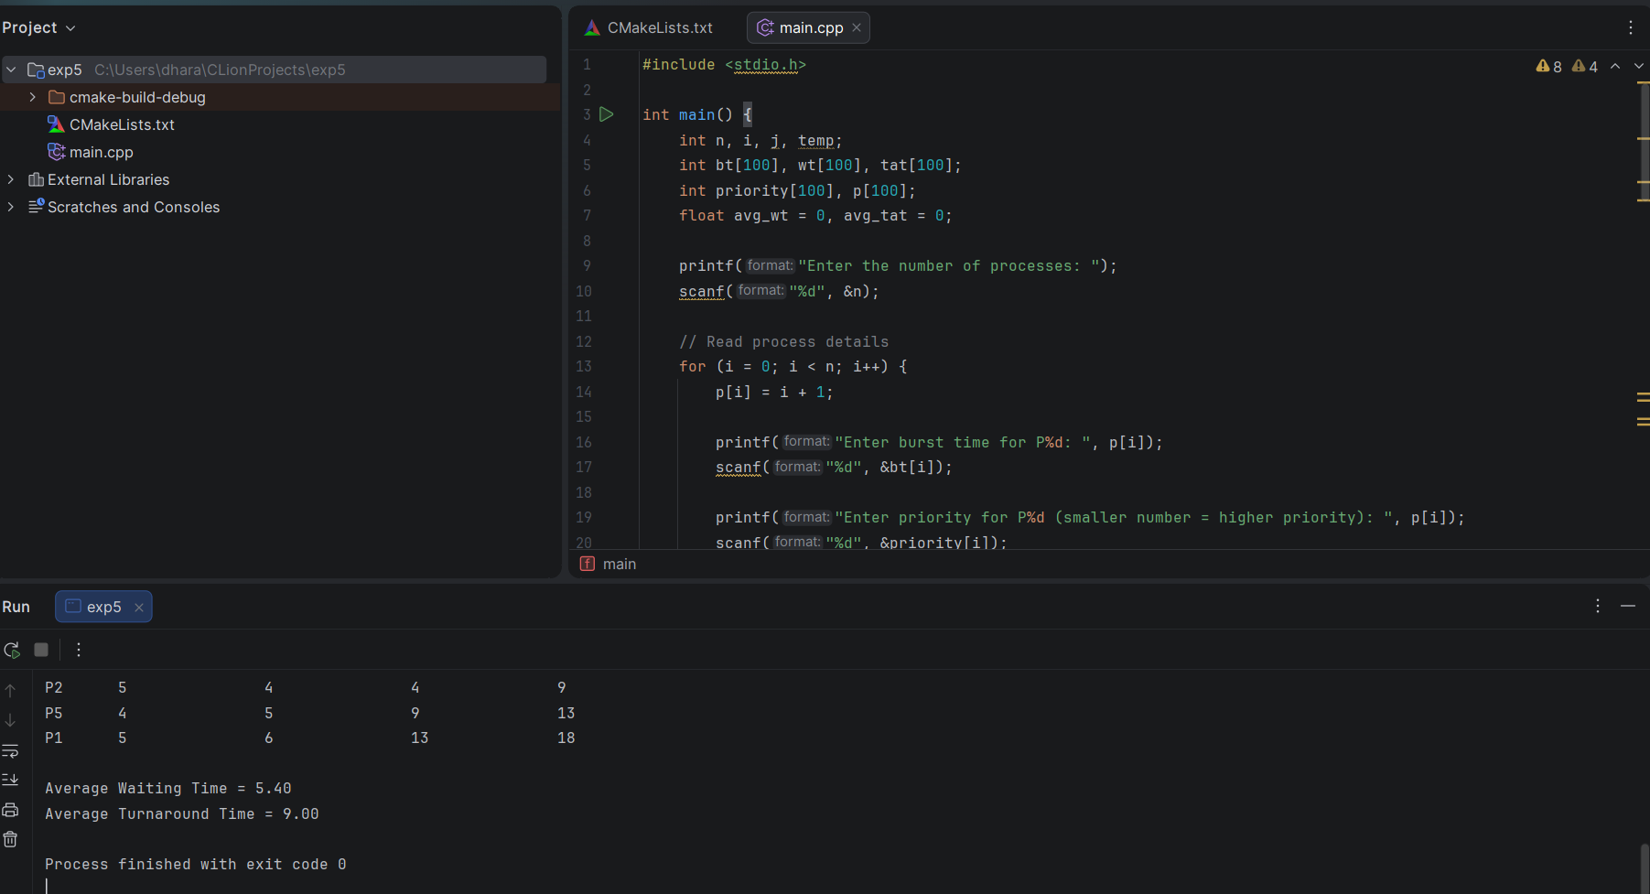

6. Construct a C program to implement pre-emptive priority scheduling algorithm.
#include <stdio.h>

int main() {
int n, i, time = 0, completed = 0;
int at[100], bt[100], rt[100];
int priority[100], wt[100], tat[100];
int ct[100], p[100];
int highest, minPriority;
float avg_wt = 0, avg_tat = 0;

printf("Enter the number of processes: ");
scanf("%d", &n);

// Input process details
for (i = 0; i < n; i++) {
p[i] = i + 1;

printf("Enter arrival time of P%d: ", p[i]);
scanf("%d", &at[i]);

printf("Enter burst time of P%d: ", p[i]);
scanf("%d", &bt[i]);

printf("Enter priority of P%d: ", p[i]);
scanf("%d", &priority[i]);

rt[i] = bt[i];
}

// Preemptive priority scheduling
while (completed < n) {
highest = -1;
minPriority = 999999;

// Find the highest-priority available process
for (i = 0; i < n; i++) {
if (at[i] <= time && rt[i] > 0) {
if (priority[i] < minPriority) {
minPriority = priority[i];
highest = i;
}
}
}

// CPU is idle if no process has arrived
if (highest == -1) {
time++;
continue;
}

// Execute the selected process for one time unit
rt[highest]--;
time++;

// Check whether the process has completed
if (rt[highest] == 0) {
completed++;
ct[highest] = time;
}
}

// Calculate waiting time and turnaround time
for (i = 0; i < n; i++) {
tat[i] = ct[i] - at[i];
wt[i] = tat[i] - bt[i];

avg_wt += wt[i];
avg_tat += tat[i];
}

avg_wt /= n;
avg_tat /= n;

// Display results
printf("\nProcess\tAT\tBT\tPriority\tWT\tTAT\tCT\n");

for (i = 0; i < n; i++) {
printf("P%d\t%d\t%d\t%d\t\t%d\t%d\t%d\n",
p[i], at[i], bt[i], priority[i],
wt[i], tat[i], ct[i]);
}

printf("\nAverage Waiting Time = %.2f\n", avg_wt);
printf("Average Turnaround Time = %.2f\n", avg_tat);

return 0;
}
